# AND GATE DATAFLOW MODEL

**VHD CODE:**

entity and_df is

Port ( A : in STD_LOGIC;

B : in STD_LOGIC;

C : out STD_LOGIC);

end and_df;

architecture dataflow of and_df is

begin

C<=A AND B;

end dataflow;

**RTL Diagram:**

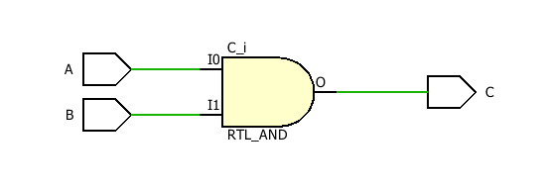

**TBW Code:**

entity and_df_tbw is

-- Port ( );

end and_df_tbw;

architecture dataflow of and_df_tbw is

component and_df is

Port ( A : in STD_LOGIC;

B : in STD_LOGIC;

C : out STD_LOGIC);

end component;

signal a1: STD_LOGIC:='0';

signal b1: STD_LOGIC:='0';

signal c1: STD_LOGIC;

begin

UUT: and_df port map(A=>a1, B=>b1, C=>c1);

Stim_proc:process

begin

wait for 100ns;

a1<='0';

b1<='0';

wait for 100ns;

a1<='0';

b1<='1';

wait for 100ns;

a1<='1';

b1<='0';

wait for 100ns;

a1<='1';

b1<='1';

wait;

end process;

end dataflow;

**TBW Waveform:**

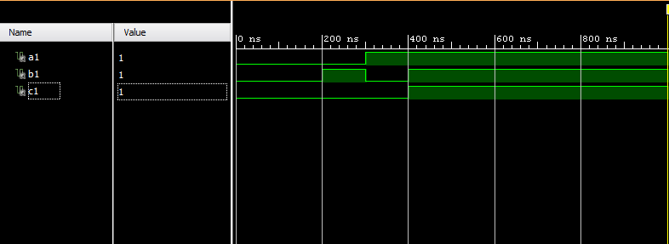

# OR GATE DATAFLOW MODEL

**VHD CODE:**

entity OR_Gate_DF is

Port ( a : in STD_LOGIC;

b : in STD_LOGIC;

c : out STD_LOGIC);

end OR_Gate_DF;

architecture Dataflow of OR_Gate_DF is

begin

c<=a or b;

end Dataflow;

**RTL Diagram:**

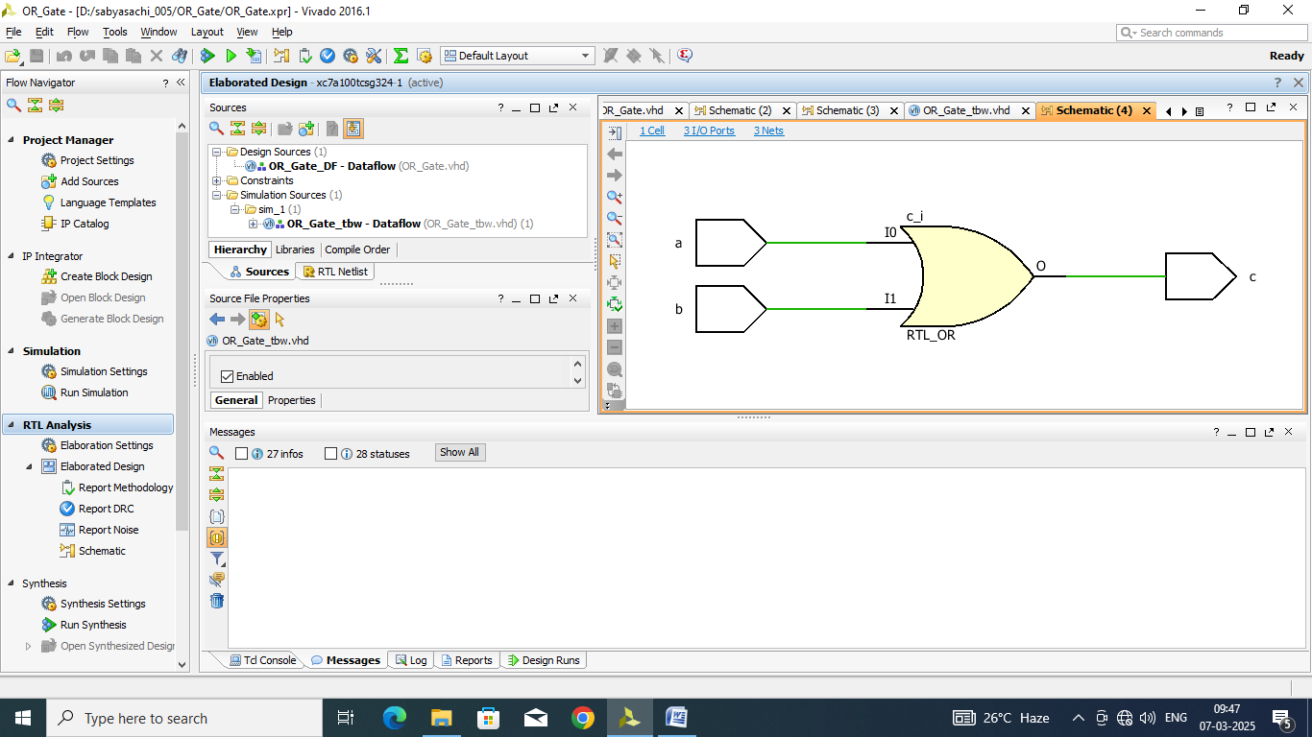

**TBW Code:**

entity OR_Gate_tbw is

-- Port ( );

end OR_Gate_tbw;

architecture Dataflow of OR_Gate_tbw is

component OR_Gate_DF is

Port ( a : in STD_LOGIC;

b : in STD_LOGIC;

c : out STD_LOGIC);

end component;

signal a1: STD_LOGIC:='0';

signal b1: STD_LOGIC:='0';

signal c1: STD_LOGIC;

begin

UUT: OR_Gate_DF port map(a=>a1, b=>b1, c=>c1);

Stim_proc:process

begin

wait for 100ns;

a1<='0';

b1<='0';

wait for 100ns;

a1<='0';

b1<='1';

wait for 100ns;

a1<='1';

b1<='0';

wait for 100ns;

a1<='1';

b1<='1';

wait;

end process;

end Dataflow;

**TBW Waveform:**

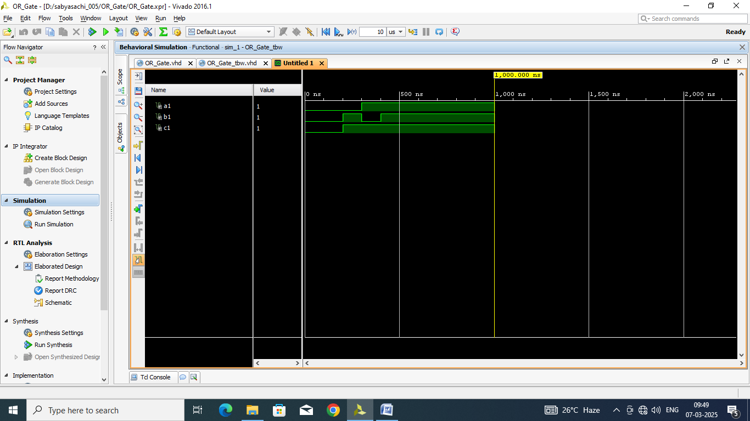

# NOT GATE DATAFLOW MODEL

**VHD CODE:**

entity NOT_Gate_df is

Port ( a : in STD_LOGIC;

b : out STD_LOGIC);

end NOT_Gate_df;

architecture Dataflow of NOT_Gate_df is

begin

b<= not a;

end Dataflow;

**RTL Diagram:**

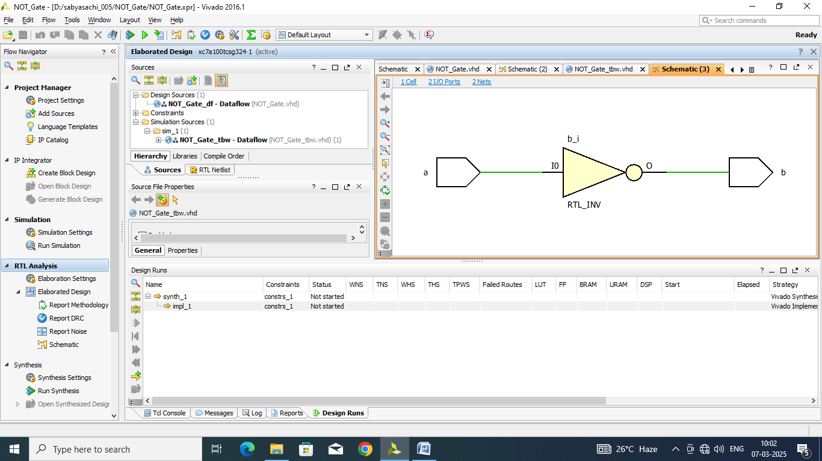

**TBW Code:**

entity NOT_Gate_tbw is

-- Port ( );

end NOT_Gate_tbw;

architecture Dataflow of NOT_Gate_tbw is

component NOT_Gate_df is

Port ( a : in STD_LOGIC;

b : out STD_LOGIC);

end component;

signal a1: STD_LOGIC:='0';

signal b1: STD_LOGIC;

begin

UUT: NOT_Gate_df port map(a=>a1, b=>b1);

Stim_proc:process

begin

wait for 100ns;

a1<='0';

wait for 100ns;

a1<='1';

wait;

end process;

end Dataflow;

**TBW Waveform:**

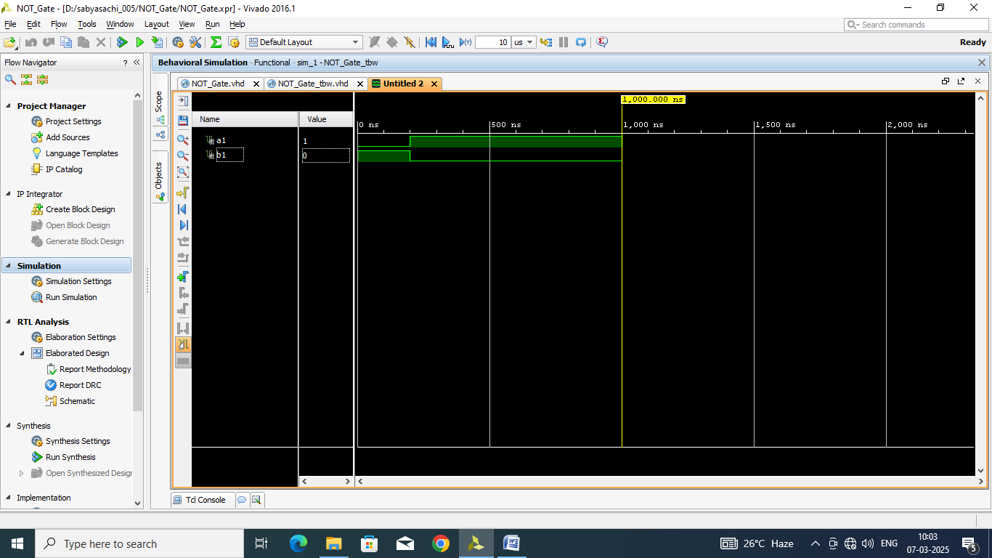

# NAND GATE DATAFLOW MODEL

**VHD CODE:**

entity NAND_Gate_DF is

Port ( a : in STD_LOGIC;

b : in STD_LOGIC;

c : out STD_LOGIC);

end NAND_Gate_DF;

architecture Dataflow of NAND_Gate_DF is

begin

c<=a nand b;

end Dataflow;

**RTL Diagram:**

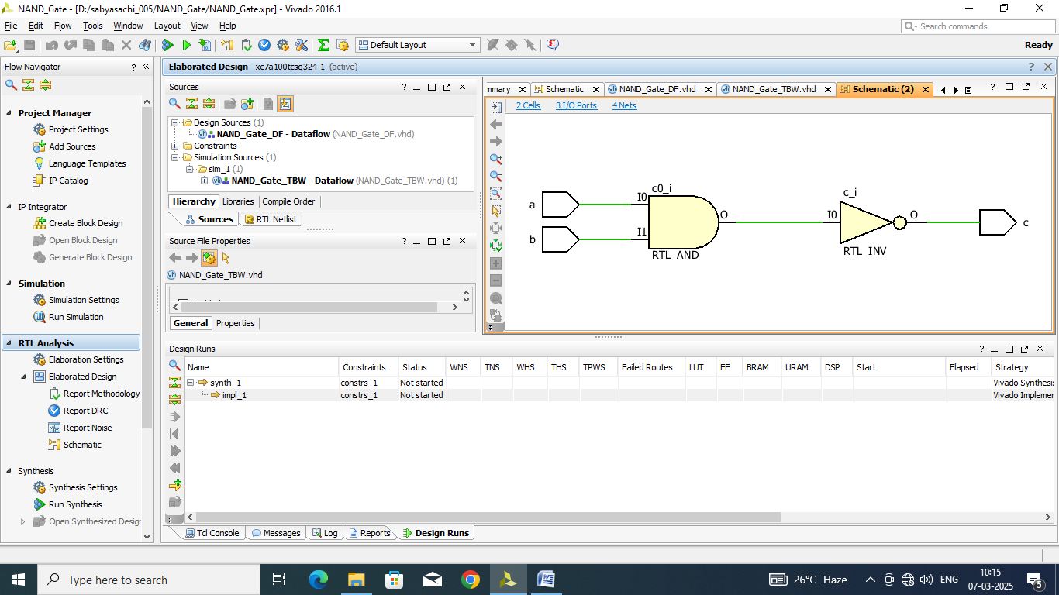

**TBW Code:**

entity NAND_Gate_TBW is

-- Port ( );

end NAND_Gate_TBW;

architecture Dataflow of NAND_Gate_TBW is

component NAND_Gate_DF is

Port ( a : in STD_LOGIC;

b : in STD_LOGIC;

c : out STD_LOGIC);

end component;

signal a1: STD_LOGIC:='0';

signal b1: STD_LOGIC:='0';

signal c1: STD_LOGIC;

begin

UUT: NAND_Gate_DF port map(a=>a1, b=>b1,c=>c1);

Stim_proc:process

begin

wait for 100ns;

a1<='0';

b1<='0';

wait for 100ns;

a1<='0';

b1<='1';

wait for 100ns;

a1<='1';

b1<='0';

wait for 100ns;

a1<='1';

b1<='1';

wait;

end process;

end Dataflow;

**TBW Waveform:**

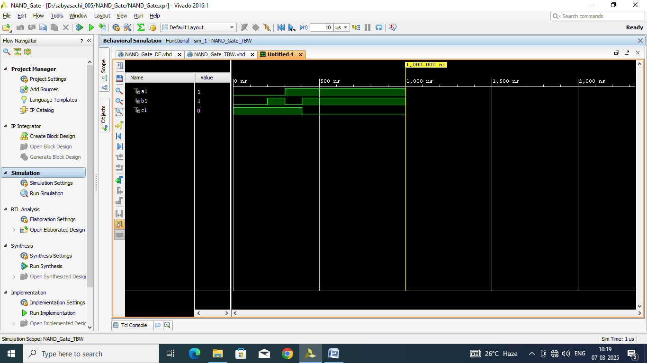

# NOR GATE DATAFLOW MODEL

**VHD CODE:**

entity NOR_Gate_DF is

Port ( a : in STD_LOGIC;

b : in STD_LOGIC;

c : out STD_LOGIC);

end NOR_Gate_DF;

architecture Dataflow of NOR_Gate_DF is

begin

c<= a nor b;

end Dataflow;

**RTL Diagram:**

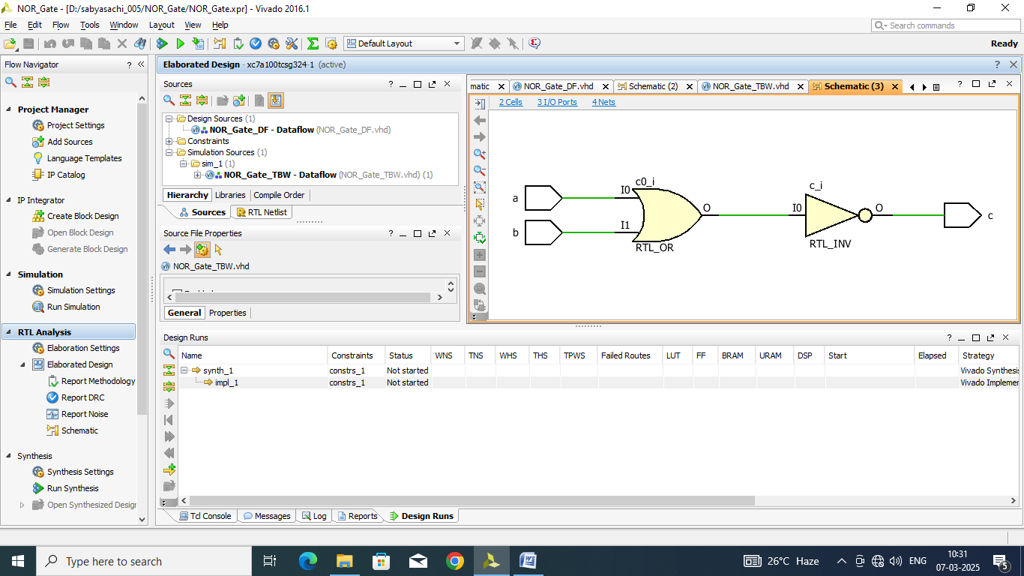

**TBW Code:**

entity NOR_Gate_TBW is

-- Port ( );

end NOR_Gate_TBW;

architecture Dataflow of NOR_Gate_TBW is

component NOR_Gate_DF is

Port ( a : in STD_LOGIC;

b : in STD_LOGIC;

c : out STD_LOGIC);

end component;

signal a1: STD_LOGIC:='0';

signal b1: STD_LOGIC:='0';

signal c1: STD_LOGIC;

begin

UUT: NOR_Gate_DF port map(a=>a1, b=>b1,c=>c1);

Stim_proc:process

begin

wait for 100ns;

a1<='0';

b1<='0';

wait for 100ns;

a1<='0';

b1<='1';

wait for 100ns;

a1<='1';

b1<='0';

wait for 100ns;

a1<='1';

b1<='1';

wait;

end process;

end Dataflow;

**TBW Waveform:**

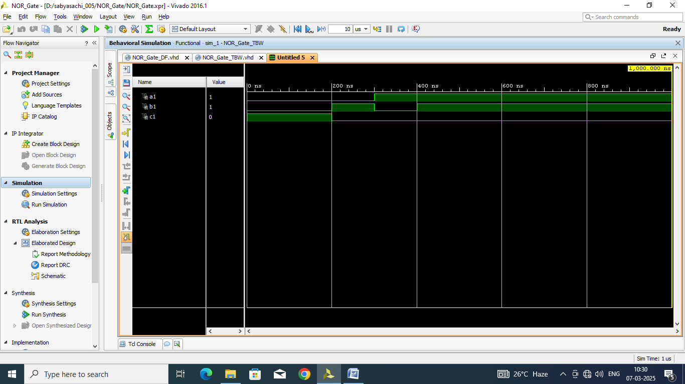

# AND Gate Using NAND Gate Dataflow

**VHD CODE:**

entity AND_NAND_DF is

Port ( A : in STD_LOGIC;

B : in STD_LOGIC;

C : out STD_LOGIC);

end AND_NAND_DF;

architecture Dataflow of AND_NAND_DF is

begin

C<= (A nand B) nand (A nand B);

end Dataflow;

**RTL Diagram:**

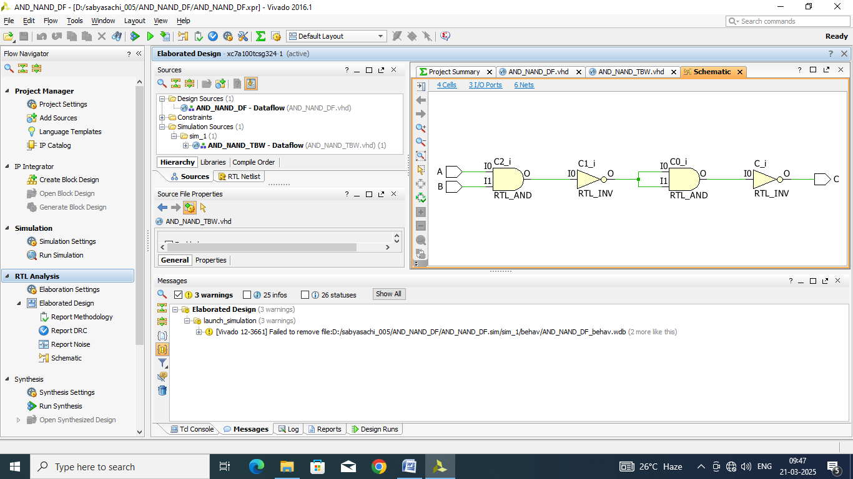

**TBW Code:**

entity AND_NAND_TBW is

-- Port ( );

end AND_NAND_TBW;

architecture Dataflow of AND_NAND_TBW is

component AND_NAND_DF is

Port ( A : in STD_LOGIC;

B : in STD_LOGIC;

C : out STD_LOGIC);

end component;

signal A1: STD_LOGIC:='0';

signal B1: STD_LOGIC:='0';

signal C1: STD_LOGIC;

begin

UUT: AND_NAND_DF port map(A=>A1, B=>B1, C=>C1);

Stim_proc:process

begin

wait for 100ns;

a1<='0';

b1<='0';

wait for 100ns;

a1<='0';

b1<='1';

wait for 100ns;

a1<='1';

b1<='0';

wait for 100ns;

a1<='1';

b1<='1';

wait;

end process;

end dataflow;

**TBW Waveform:**

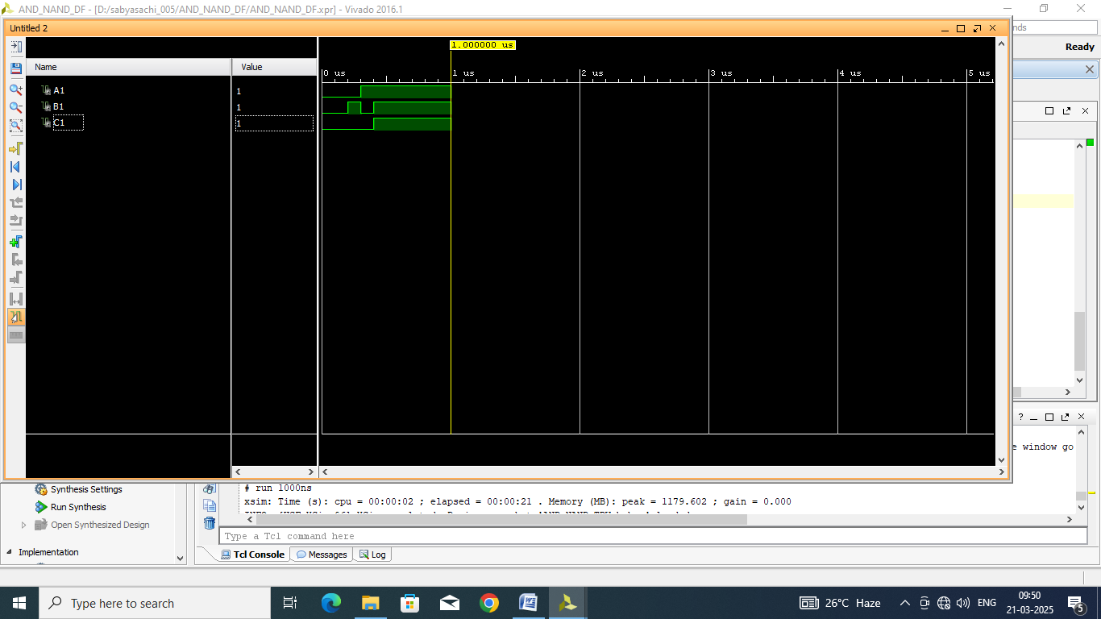

# OR Gate Using NAND Gate Dataflow

**VHD CODE:**

entity OR_NAND_DF is

Port ( A : in STD_LOGIC;

B : in STD_LOGIC;

C : out STD_LOGIC);

end OR_NAND_DF;

architecture Dataflow of OR_NAND_DF is

begin

C<= (A nand A) nand (B nand B);

end Dataflow;

**RTL Diagram:**

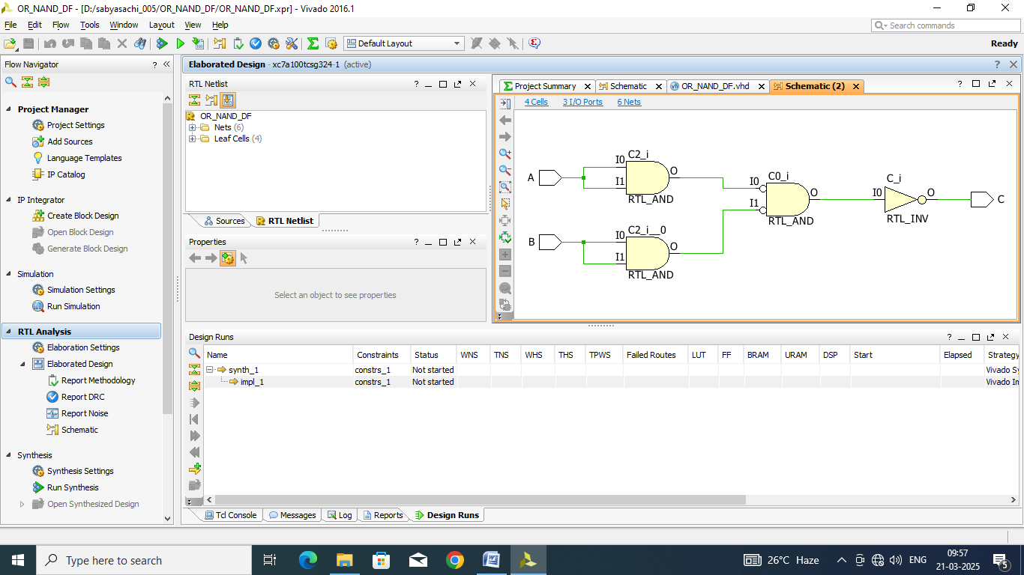

**TBW Code:**

entity OR_NAND_TBW is

-- Port ( );

end OR_NAND_TBW;

architecture Dataflow of OR_NAND_TBW is

component OR_NAND_DF is

Port ( A : in STD_LOGIC;

B : in STD_LOGIC;

C : out STD_LOGIC);

end component;

signal A1: STD_LOGIC:='0';

signal B1: STD_LOGIC:='0';

signal C1: STD_LOGIC;

begin

UUT: OR_NAND_DF port map(A=>A1, B=>B1, C=>C1);

Stim_proc:process

begin

wait for 100ns;

a1<='0';

b1<='0';

wait for 100ns;

a1<='0';

b1<='1';

wait for 100ns;

a1<='1';

b1<='0';

wait for 100ns;

a1<='1';

b1<='1';

wait;

end process;

end dataflow;

**TBW Waveform:**

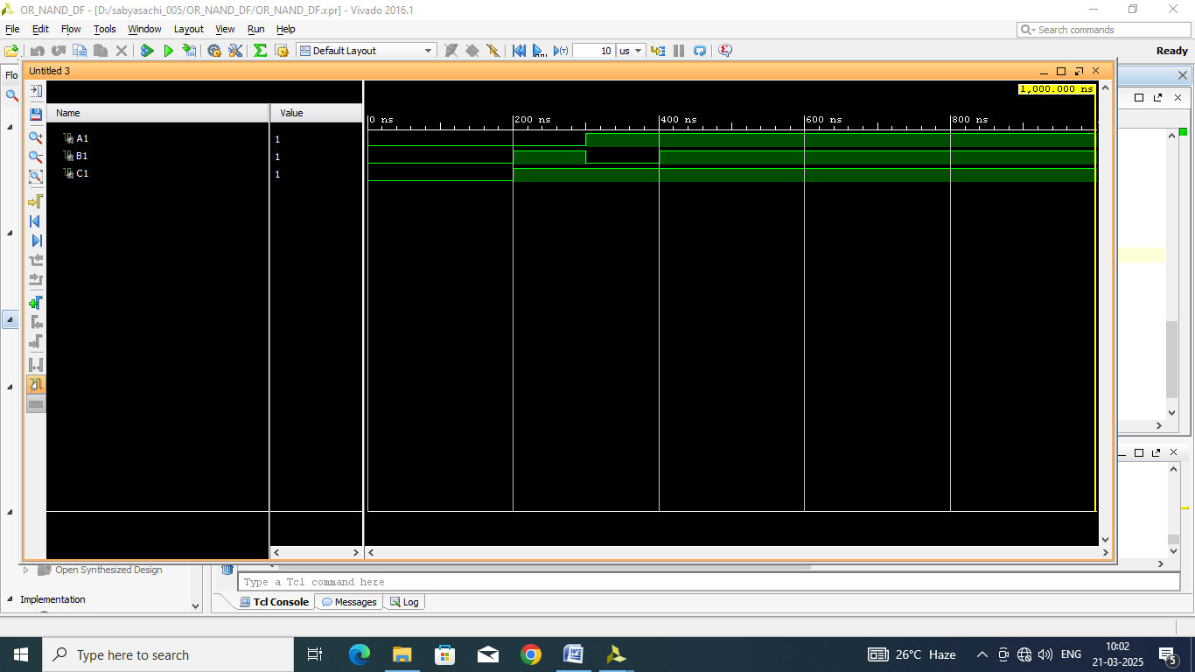

# not Gate Using NAND Gate Dataflow

**VHD CODE:**

entity NOT_NAND_DF is

Port ( A : in STD_LOGIC;

B : out STD_LOGIC);

end NOT_NAND_DF;

architecture Dataflow of NOT_NAND_DF is

begin

B <= A nand A;

end Dataflow;

**RTL Diagram:**

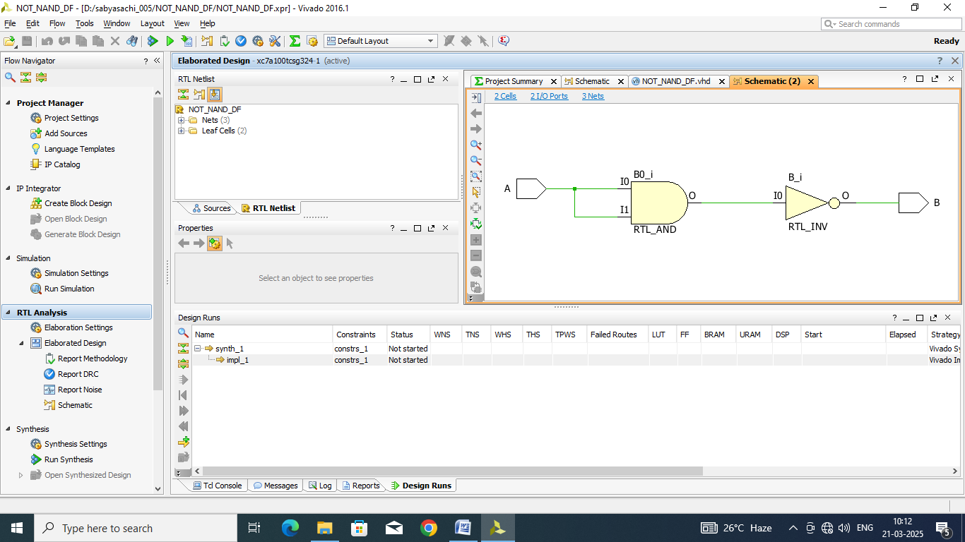

**TBW Code:**

entity NOT_NAND_TBW is

-- Port ( );

end NOT_NAND_TBW;

architecture Dataflow of NOT_NAND_TBW is

component NOT_NAND_DF is

Port ( A : in STD_LOGIC;

B : out STD_LOGIC);

end component;

signal A1: STD_LOGIC:='0';

signal B1: STD_LOGIC;

begin

UUT: NOT_NAND_DF port map(A=>A1, B=>B1);

Stim_proc:process

begin

wait for 100ns;

a1<='0';

wait for 100ns;

a1<='1';

wait;

end process;

end dataflow;

**TBW Waveform:**

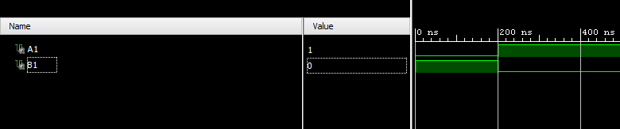

# XOR Gate Using NAND Gate Dataflow

**VHD CODE:**

entity XOR_NAND_DF is

Port ( A : in STD_LOGIC;

B : in STD_LOGIC;

C : out STD_LOGIC);

end XOR_NAND_DF;

architecture Dataflow of XOR_NAND_DF is

begin

C<= (((A nand A) nand B) nand ((B nand B) nand A));

end Dataflow;

**RTL Diagram:**

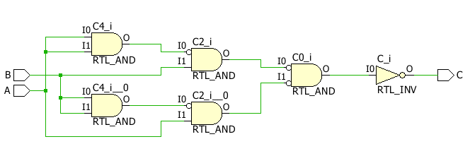

**TBW Code:**

entity XOR_NAND_TBW is

-- Port ( );

end XOR_NAND_TBW;

architecture Dataflow of XOR_NAND_TBW is

component XOR_NAND_DF is

Port ( A : in STD_LOGIC;

B : in STD_LOGIC;

C : out STD_LOGIC);

end component;

signal A1: STD_LOGIC:='0';

signal B1: STD_LOGIC:='0';

signal C1: STD_LOGIC;

begin

UUT: XOR_NAND_DF port map(A=>A1, B=>B1, C=>C1);

Stim_proc:process

begin

wait for 100ns;

a1<='0';

b1<='0';

wait for 100ns;

a1<='0';

b1<='1';

wait for 100ns;

a1<='1';

b1<='0';

wait for 100ns;

a1<='1';

b1<='1';

wait;

end process;

end dataflow;

**TBW Waveform:**

# 

# XNOR Gate Using NAND Gate Dataflow

**VHD CODE:**

entity XNOR_NAND_DF is

Port ( A : in STD_LOGIC;

B : in STD_LOGIC;

C : out STD_LOGIC);

end XNOR_NAND_DF;

architecture Dataflow of XNOR_NAND_DF is

begin

C<= (A nand B) nand ((A nand A) nand (B nand B));

end Dataflow;

**RTL Diagram:**

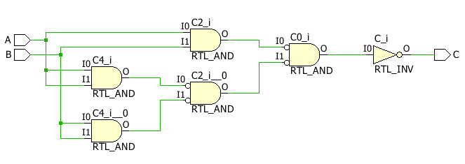

**TBW Code:**

entity XNOR_NAND_TBW is

-- Port ( );

end XNOR_NAND_TBW;

architecture Dataflow of XNOR_NAND_TBW is

component XNOR_NAND_DF is

Port ( A : in STD_LOGIC;

B : in STD_LOGIC;

C : out STD_LOGIC);

end component;

signal A1: STD_LOGIC:='0';

signal B1: STD_LOGIC:='0';

signal C1: STD_LOGIC;

begin

UUT: XNOR_NAND_DF port map(A=>A1, B=>B1, C=>C1);

Stim_proc:process

begin

wait for 100ns;

a1<='0';

b1<='0';

wait for 100ns;

a1<='0';

b1<='1';

wait for 100ns;

a1<='1';

b1<='0';

wait for 100ns;

a1<='1';

b1<='1';

wait;

end process;

end dataflow;

**TBW Waveform:**

# 

# XOR Gate Dataflow

**VHD CODE:**

entity XOR_GATE_DF is

Port ( A : in STD_LOGIC;

B : in STD_LOGIC;

C : out STD_LOGIC);

end XOR_GATE_DF;

architecture Dataflow of XOR_GATE_DF is

begin

C<= A xor B;

end Dataflow;

**RTL Diagram:**

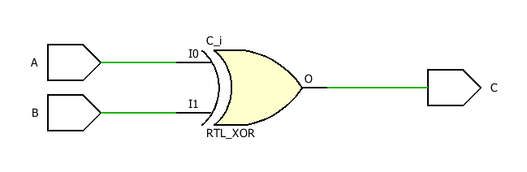

**TBW Code:**

entity XOR_GATE_TBW is

-- Port ( );

end XOR_GATE_TBW;

architecture Dataflow of XOR_GATE_TBW is

component XOR_GATE_DF is

Port ( A : in STD_LOGIC;

B : in STD_LOGIC;

C : out STD_LOGIC);

end component;

signal A1: STD_LOGIC:='0';

signal B1: STD_LOGIC:='0';

signal C1: STD_LOGIC;

begin

UUT: XOR_GATE_DF port map(A=>A1, B=>B1, C=>C1);

Stim_proc:process

begin

wait for 100ns;

a1<='0';

b1<='0';

wait for 100ns;

a1<='0';

b1<='1';

wait for 100ns;

a1<='1';

b1<='0';

wait for 100ns;

a1<='1';

b1<='1';

wait;

end process;

end dataflow;

**TBW Waveform:**

# 

# XNOR Gate Dataflow

**VHD CODE:**

entity XNOR_GATE_DF is

Port ( A : in STD_LOGIC;

B : in STD_LOGIC;

C : out STD_LOGIC);

end XNOR_GATE_DF;

architecture Dataflow of XNOR_GATE_DF is

begin

C<= A xnor B;

end Dataflow;

**RTL Diagram:**

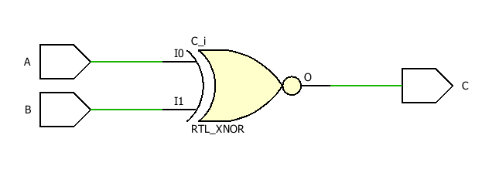

**TBW Code:**

entity XNOR_GATE_TBW is

-- Port ( );

end XNOR_GATE_TBW;

architecture Dataflow of XNOR_GATE_TBW is

component XNOR_GATE_DF is

Port ( A : in STD_LOGIC;

B : in STD_LOGIC;

C : out STD_LOGIC);

end component;

signal A1: STD_LOGIC:='0';

signal B1: STD_LOGIC:='0';

signal C1: STD_LOGIC;

begin

UUT: XNOR_GATE_DF port map(A=>A1, B=>B1, C=>C1);

Stim_proc:process

begin

wait for 100ns;

a1<='0';

b1<='0';

wait for 100ns;

a1<='0';

b1<='1';

wait for 100ns;

a1<='1';

b1<='0';

wait for 100ns;

a1<='1';

b1<='1';

wait;

end process;

end dataflow;

**TBW Waveform:**

# 

# AND Gate using nor Dataflow

**VHD CODE:**

entity AND_NOR_DF is

Port ( A : in STD_LOGIC;

B : in STD_LOGIC;

C : out STD_LOGIC);

end AND_NOR_DF;

architecture Dataflow of AND_NOR_DF is

begin

C<= (A nor A) nor (B nor B);

end Dataflow;

**RTL Diagram:**

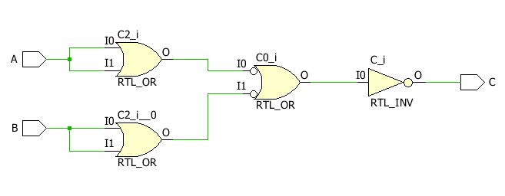

**TBW Code:**

entity AND_NOR_TBW is

-- Port ( );

end AND_NOR_TBW;

architecture Dataflow of AND_NOR_TBW is

component AND_NOR_DF is

Port ( A : in STD_LOGIC;

B : in STD_LOGIC;

C : out STD_LOGIC);

end component;

signal A1: STD_LOGIC:='0';

signal B1: STD_LOGIC:='0';

signal C1: STD_LOGIC;

begin

UUT: AND_NOR_DF port map(A=>A1, B=>B1, C=>C1);

Stim_proc:process

begin

wait for 100ns;

a1<='0';

b1<='0';

wait for 100ns;

a1<='0';

b1<='1';

wait for 100ns;

a1<='1';

b1<='0';

wait for 100ns;

a1<='1';

b1<='1';

wait;

end process;

end dataflow;

**TBW Waveform:**

# 

# OR Gate using nor Dataflow

**VHD CODE:**

entity OR_NOR_DF is

Port ( A : in STD_LOGIC;

B : in STD_LOGIC;

C : out STD_LOGIC);

end OR_NOR_DF;

architecture Dataflow of OR_NOR_DF is

begin

C<= not(A nor B);

end Dataflow;

**RTL Diagram:**

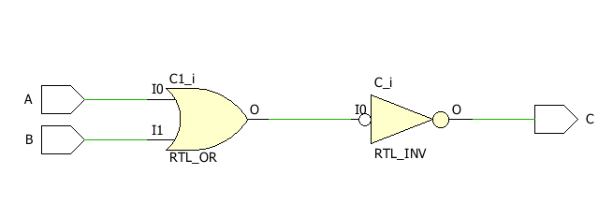

**TBW Code:**

entity OR_NOR_TBW is

-- Port ( );

end OR_NOR_TBW;

architecture Dataflow of OR_NOR_TBW is

component OR_NOR_DF is

Port ( A : in STD_LOGIC;

B : in STD_LOGIC;

C : out STD_LOGIC);

end component;

signal A1: STD_LOGIC:='0';

signal B1: STD_LOGIC:='0';

signal C1: STD_LOGIC;

begin

UUT: OR_NOR_DF port map(A=>A1, B=>B1, C=>C1);

Stim_proc:process

begin

wait for 100ns;

a1<='0';

b1<='0';

wait for 100ns;

a1<='0';

b1<='1';

wait for 100ns;

a1<='1';

b1<='0';

wait for 100ns;

a1<='1';

b1<='1';

wait;

end process;

end dataflow;

**TBW Waveform:**

# 

# NOT Gate using nor Dataflow

**VHD CODE:**

entity NOT_NOR_DF is

Port ( A : in STD_LOGIC;

B : out STD_LOGIC);

end NOT_NOR_DF;

architecture Dataflow of NOT_NOR_DF is

begin

B<= A nor A;

end Dataflow;

**RTL Diagram:**

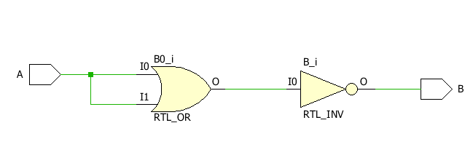

**TBW Code:**

entity NOT_NOR_TBW is

-- Port ( );

end NOT_NOR_TBW;

architecture Dataflow of NOT_NOR_TBW is

component NOT_NOR_DF is

Port ( A : in STD_LOGIC;

B : out STD_LOGIC);

end component;

signal A1: STD_LOGIC:='0';

signal B1: STD_LOGIC;

begin

UUT: NOT_NOR_DF port map(A=>A1, B=>B1);

Stim_proc:process

begin

wait for 100ns;

a1<='0';

wait for 100ns;

a1<='1';

wait;

end process;

end dataflow;

**TBW Waveform:**

# 

# XOR Gate using nor Dataflow

**VHD CODE:**

entity XOR_NOR_DF is

Port ( A : in STD_LOGIC;

B : in STD_LOGIC;

C : out STD_LOGIC);

end XOR_NOR_DF;

architecture Dataflow of XOR_NOR_DF is

begin

C<= (A nor B) nor ((A nor A) nor (B nor B));

end Dataflow;

**RTL Diagram:**

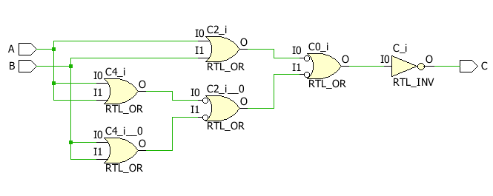

**TBW Code:**

entity XOR_NOR_TBW is

-- Port ( );

end XOR_NOR_TBW;

architecture Dataflow of XOR_NOR_TBW is

component XOR_NOR_DF is

Port ( A : in STD_LOGIC;

B : in STD_LOGIC;

C : out STD_LOGIC);

end component;

signal A1: STD_LOGIC:='0';

signal B1: STD_LOGIC:='0';

signal C1: STD_LOGIC;

begin

UUT: XOR_NOR_DF port map(A=>A1, B=>B1, C=>C1);

Stim_proc:process

begin

wait for 100ns;

a1<='0';

b1<='0';

wait for 100ns;

a1<='0';

b1<='1';

wait for 100ns;

a1<='1';

b1<='0';

wait for 100ns;

a1<='1';

b1<='1';

wait;

end process;

end dataflow;

**TBW Waveform:**

# 

# XNOR Gate using nor Dataflow

**VHD CODE:**

entity XNOR_NOR_DF is

Port ( A : in STD_LOGIC;

B : in STD_LOGIC;

C : out STD_LOGIC);

end XNOR_NOR_DF;

architecture Dataflow of XNOR_NOR_DF is

begin

C<= ((A NOR A) NOR B) NOR (A NOR (B NOR B));

end Dataflow;

**RTL Diagram:**

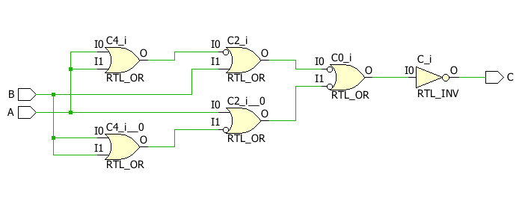

**TBW Code:**

entity XNOR_NOR_TBW is

-- Port ( );

end XNOR_NOR_TBW;

architecture Dataflow of XNOR_NOR_TBW is

component XNOR_NOR_DF is

Port ( A : in STD_LOGIC;

B : in STD_LOGIC;

C : out STD_LOGIC);

end component;

signal A1: STD_LOGIC:='0';

signal B1: STD_LOGIC:='0';

signal C1: STD_LOGIC;

begin

UUT: XNOR_NOR_DF port map(A=>A1, B=>B1, C=>C1);

Stim_proc:process

begin

wait for 100ns;

a1<='0';

b1<='1';

wait for 100ns;

a1<='1';

b1<='0';

wait for 100ns;

a1<='1';

b1<='1';

wait;

end process;

end dataflow;

**TBW Waveform:**

# 

# AND IF Behavioral

**VHD CODE:**

entity AND_IF_BH is

Port ( A : in STD_LOGIC;

B : in STD_LOGIC;

C : out STD_LOGIC);

end AND_IF_BH;

architecture Behavioral of AND_IF_BH is

begin

process(A,B)

begin

if(A='1' and B='1') then

C<='1';

else

C<='0';

end if;

end process;

end Behavioral;

**RTL Diagram:**

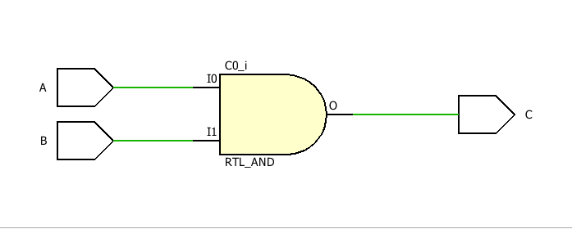

**TBW Code:**

entity AND_IF_TBW is

-- Port ( );

end AND_IF_TBW;

architecture Behavioral of AND_IF_TBW is

component AND_IF_BH is

Port ( A : in STD_LOGIC;

B : in STD_LOGIC;

C : out STD_LOGIC);

end component;

signal A1: STD_LOGIC:='0';

signal B1: STD_LOGIC:='0';

signal C1: STD_LOGIC;

begin

UUT: AND_IF_BH port map(A=>A1, B=>B1, C=>C1);

Stim_proc:process

begin

wait for 100ns;

A1<='0';

B1<='1';

wait for 100ns;

A1<='1';

B1<='0';

wait for 100ns;

A1<='1';

B1<='1';

wait;

end process;

end Behavioral;

**TBW Waveform:**

# 

# OR IF Behavioral

**VHD CODE:**

entity OR_IF_BH is

Port ( A : in STD_LOGIC;

B : in STD_LOGIC;

C : out STD_LOGIC);

end OR_IF_BH;

architecture Behavioral of OR_IF_BH is

begin

process(A,B)

begin

if(A='1' OR B='1') then

C<='1';

else

C<='0';

end if;

end process;

end Behavioral;

**RTL Diagram:**

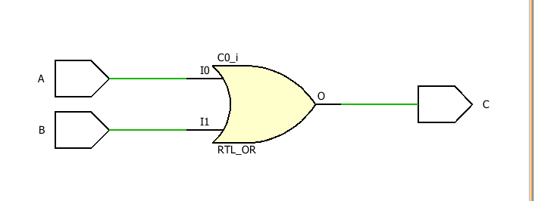

**TBW Code:**

entity OR_IF_TBW is

-- Port ( );

end OR_IF_TBW;

architecture Behavioral of OR_IF_TBW is

component OR_IF_BH is

Port ( A : in STD_LOGIC;

B : in STD_LOGIC;

C : out STD_LOGIC);

end component;

signal A1: STD_LOGIC:='0';

signal B1: STD_LOGIC:='0';

signal C1: STD_LOGIC;

begin

UUT: OR_IF_BH port map(A=>A1, B=>B1, C=>C1);

Stim_proc:process

begin

wait for 100ns;

A1<='0';

B1<='1';

wait for 100ns;

A1<='1';

B1<='0';

wait for 100ns;

A1<='1';

B1<='1';

wait;

end process;

end Behavioral;

**TBW Waveform:**

# 

# not IF Behavioral

**VHD CODE:**

entity NOT_IF_BH is

Port ( A : in STD_LOGIC;

B : out STD_LOGIC);

end NOT_IF_BH;

architecture Behavioral of NOT_IF_BH is

begin

process(A)

begin

if(A='1') then

B<='0';

else

B<='1';

end if;

end process;

end Behavioral;

**RTL Diagram:**

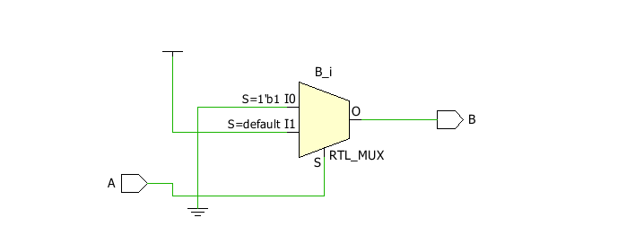

**TBW Code:**

entity NOT_IF_TBW is

-- Port ( );

end NOT_IF_TBW;

architecture Behavioral of NOT_IF_TBW is

component NOT_IF_BH is

Port ( A : in STD_LOGIC;

B : out STD_LOGIC);

end component;

signal A1: STD_LOGIC:='0';

signal B1: STD_LOGIC;

begin

UUT: NOT_IF_BH port map(A=>A1, B=>B1);

Stim_proc:process

begin

wait for 100ns;

A1<='0';

wait for 100ns;

A1<='1';

wait;

end process;

end Behavioral;

**TBW Waveform:**

# 

# NAND IF Behavioral

**VHD CODE:**

entity NAND_IF_BH is

Port ( A : in STD_LOGIC;

B : in STD_LOGIC;

C : out STD_LOGIC);

end NAND_IF_BH;

architecture Behavioral of NAND_IF_BH is

begin

process(A,B)

begin

if(A='1' AND B='1') then

C<='0';

else

C<='1';

end if;

end process;

end Behavioral;

**RTL Diagram:**

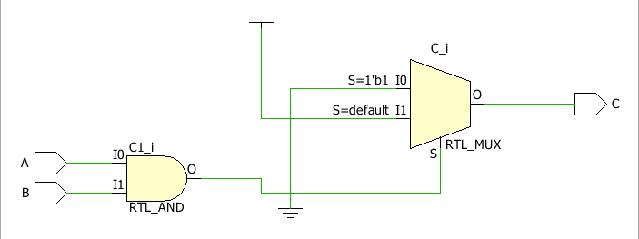

**TBW Code:**

entity NAND_IF_TBW is

-- Port ( );

end NAND_IF_TBW;

architecture Behavioral of NAND_IF_TBW is

component NAND_IF_BH is

Port ( A : in STD_LOGIC;

B : in STD_LOGIC;

C : out STD_LOGIC);

end component;

signal A1: STD_LOGIC:='0';

signal B1: STD_LOGIC:='0';

signal C1: STD_LOGIC;

begin

UUT: NAND_IF_BH port map(A=>A1, B=>B1, C=>C1);

Stim_proc:process

begin

wait for 100ns;

A1<='0';

B1<='1';

wait for 100ns;

A1<='1';

B1<='0';

wait for 100ns;

A1<='1';

B1<='1';

wait;

end process;

end Behavioral;

**TBW Waveform:**

# 

# NOR IF Behavioral

**VHD CODE:**

entity NOR_IF_BH is

Port ( A : in STD_LOGIC;

B : in STD_LOGIC;

C : out STD_LOGIC);

end NOR_IF_BH;

architecture Behavioral of NOR_IF_BH is

begin

process(A,B)

begin

if(A='0' AND B='0') then

C<='1';

else

C<='0';

end if;

end process;

end Behavioral;

**RTL Diagram:**

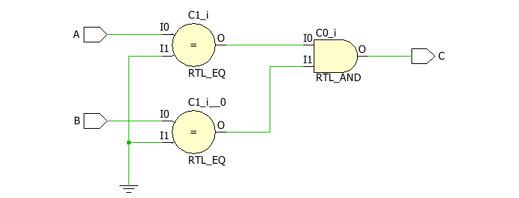

**TBW Code:**

entity NOR_IF_TBW is

-- Port ( );

end NOR_IF_TBW;

architecture Behavioral of NOR_IF_TBW is

component NOR_IF_BH is

Port ( A : in STD_LOGIC;

B : in STD_LOGIC;

C : out STD_LOGIC);

end component;

signal A1: STD_LOGIC:='0';

signal B1: STD_LOGIC:='0';

signal C1: STD_LOGIC;

begin

UUT: NOR_IF_BH port map(A=>A1, B=>B1, C=>C1);

Stim_proc:process

begin

wait for 100ns;

A1<='0';

B1<='1';

wait for 100ns;

A1<='1';

B1<='0';

wait for 100ns;

A1<='1';

B1<='1';

wait;

end process;

end Behavioral;

**TBW Waveform:**

# 

# XOR IF Behavioral

**VHD CODE:**

entity XOR_IF_BH is

Port ( A : in STD_LOGIC;

B : in STD_LOGIC;

C : out STD_LOGIC);

end XOR_IF_BH;

architecture Behavioral of XOR_IF_BH is

begin

process(A,B)

begin

if(A=B) then

C<='0';

else

C<='1';

end if;

end process;

end Behavioral;

**RTL Diagram:**

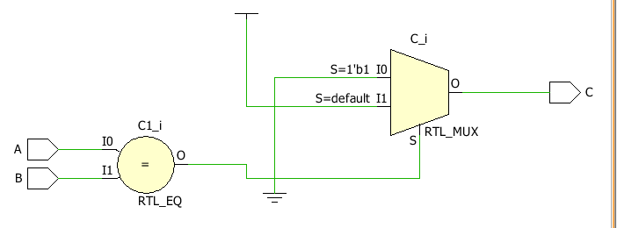

**TBW Code:**

entity XOR_IF_TBW is

-- Port ( );

end XOR_IF_TBW;

architecture Behavioral of XOR_IF_TBW is

component XOR_IF_BH is

Port ( A : in STD_LOGIC;

B : in STD_LOGIC;

C : out STD_LOGIC);

end component;

signal A1: STD_LOGIC:='0';

signal B1: STD_LOGIC:='0';

signal C1: STD_LOGIC;

begin

UUT: XOR_IF_BH port map(A=>A1, B=>B1, C=>C1);

Stim_proc:process

begin

wait for 100ns;

A1<='0';

B1<='1';

wait for 100ns;

A1<='1';

B1<='0';

wait for 100ns;

A1<='1';

B1<='1';

wait;

end process;

end Behavioral;

**TBW Waveform:**

# 

# XNOR IF Behavioral

**VHD CODE:**

entity XNOR_IF_BH is

Port ( A : in STD_LOGIC;

B : in STD_LOGIC;

C : out STD_LOGIC);

end XNOR_IF_BH;

architecture Behavioral of XNOR_IF_BH is

begin

process(A,B)

begin

if(A=B) then

C<='1';

else

C<='0';

end if;

end process;

end Behavioral;

**RTL Diagram:**

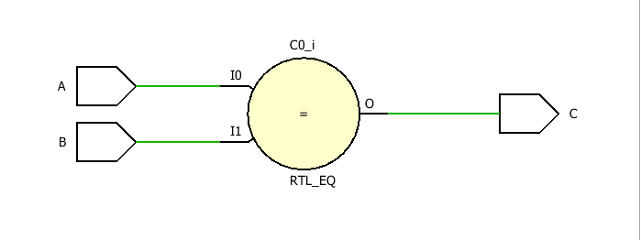

**TBW Code:**

entity XNOR_IF_TBW is

-- Port ( );

end XNOR_IF_TBW;

architecture Behavioral of XNOR_IF_TBW is

component XNOR_IF_BH is

Port ( A : in STD_LOGIC;

B : in STD_LOGIC;

C : out STD_LOGIC);

end component;

signal A1: STD_LOGIC:='0';

signal B1: STD_LOGIC:='0';

signal C1: STD_LOGIC;

begin

UUT: XNOR_IF_BH port map(A=>A1, B=>B1, C=>C1);

Stim_proc:process

begin

wait for 100ns;

A1<='0';

B1<='1';

wait for 100ns;

A1<='1';

B1<='0';

wait for 100ns;

A1<='1';

B1<='1';

wait;

end process;

end Behavioral;

**TBW Waveform:**

# 

# HFADD Behavioral

**VHD CODE:**

entity HFADD_BH is

Port ( A : in STD_LOGIC;

B : in STD_LOGIC;

C : out STD_LOGIC;

S : out STD_LOGIC);

end HFADD_BH;

architecture Behavioral of HFADD_BH is

begin

process(A,B)

begin

if(A=B) then

S<='0';

else

S<='1';

end if;

if(A='1' AND B='1') then

C<='1';

else

C<='0';

end if;

end process;

end Behavioral;

**RTL Diagram:**

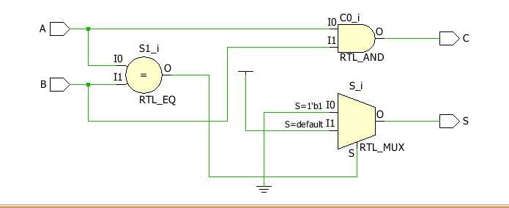

**TBW Code:**

entity HFADD_TBW is

-- Port ( );

end HFADD_TBW;

architecture Behavioral of HFADD_TBW is

component HFADD_BH is

Port ( A : in STD_LOGIC;

B : in STD_LOGIC;

S : out STD_LOGIC;

C : out STD_LOGIC);

end component;

signal A1: STD_LOGIC:='0';

signal B1: STD_LOGIC:='0';

signal C1: STD_LOGIC;

signal S1: STD_LOGIC;

begin

UUT: HFADD_BH port map(A=>A1, B=>B1, C=>C1, S=>S1);

Stim_proc:process

begin

wait for 100ns;

A1<='0';

B1<='1';

wait for 100ns;

A1<='1';

B1<='0';

wait for 100ns;

A1<='1';

B1<='1';

wait;

end process;

end Behavioral;

**TBW Waveform:**

# 

# HFADD DATAFLOW

**VHD CODE:**

entity HFADD_DF is

Port ( A : in STD_LOGIC;

B : in STD_LOGIC;

S : out STD_LOGIC;

C : out STD_LOGIC);

end HFADD_DF;

architecture Dataflow of HFADD_DF is

begin

S<= A XOR B;

C<= A AND B;

end Dataflow;

**RTL Diagram:**

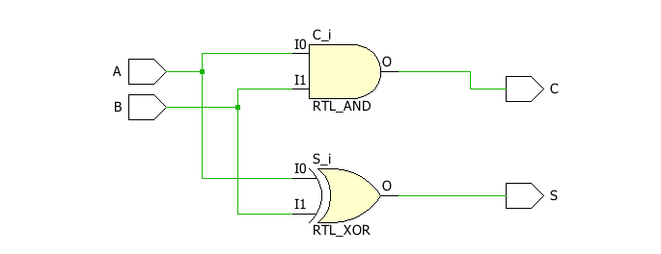

**TBW Code:**

entity HFADD_TBW is

-- Port ( );

end HFADD_TBW;

architecture Dataflow of HFADD_TBW is

component HFADD_DF is

Port ( A : in STD_LOGIC;

B : in STD_LOGIC;

S : out STD_LOGIC;

C : out STD_LOGIC);

end component;

signal A1: STD_LOGIC:='0';

signal B1: STD_LOGIC:='0';

signal C1: STD_LOGIC;

signal S1: STD_LOGIC;

begin

UUT: HFADD_DF port map(A=>A1, B=>B1, C=>C1, S=>S1);

Stim_proc:process

begin

wait for 100ns;

A1<='0';

B1<='1';

wait for 100ns;

A1<='1';

B1<='0';

wait for 100ns;

A1<='1';

B1<='1';

wait;

end process;

end Dataflow;

**TBW Waveform:**

# 

# FULLADD Behavioral

**VHD CODE:**

entity FULLADD_BH is

Port ( A : in STD_LOGIC;

B : in STD_LOGIC;

Cin : in STD_LOGIC;

S : out STD_LOGIC;

Cout : out STD_LOGIC);

end FULLADD_BH;

architecture Behavioral of FULLADD_BH is

begin

process(A,B,Cin)

begin

if(A='0') then

if(B=Cin) then

S<='0';

else

S<='1';

end if;

else

if(B=Cin) then

S<='1';

else

S<='0';

end if;

end if;

if((A='1' and B='1') or (B='1' and Cin='1') or (Cin='1' and A='1')) then

Cout<='1';

else

Cout<='0';

end if;

end process;

end Behavioral;

**RTL Diagram:**

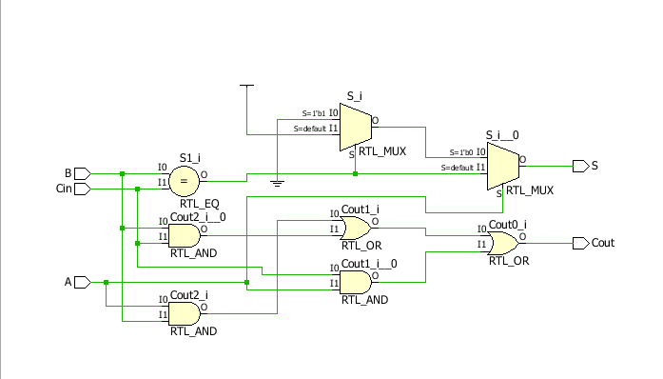

**TBW Code:**

entity FULLADD_TBW is

-- Port ( );

end FULLADD_TBW;

architecture Behavioral of FULLADD_TBW is

component FULLADD_BH is

Port ( A : in STD_LOGIC;

B : in STD_LOGIC;

Cin : in STD_LOGIC;

S : out STD_LOGIC;

Cout : out STD_LOGIC);

end component;

signal A1: STD_LOGIC:='0';

signal B1: STD_LOGIC:='0';

signal Cin1: STD_LOGIC:='0';

signal S1: STD_LOGIC;

signal Cout1: STD_LOGIC;

begin

UUT: FULLADD_BH port map(A=>A1, B=>B1, Cin=>Cin1, S=>S1, Cout=>Cout1);

Stim_proc:process

begin

wait for 100ns;

A1<='0';

B1<='0';

Cin1<='1';

wait for 100ns;

A1<='0';

B1<='1';

Cin1<='0';

wait for 100ns;

A1<='0';

B1<='1';

Cin1<='1';

wait for 100ns;

A1<='1';

B1<='0';

Cin1<='0';

wait for 100ns;

A1<='1';

B1<='0';

Cin1<='1';

wait for 100ns;

A1<='1';

B1<='1';

Cin1<='0';

wait for 100ns;

A1<='1';

B1<='1';

Cin1<='1';

wait;

end process;

end Behavioral;

**TBW Waveform:**

# 

# fULLADD DATAFLOW

**VHD CODE:**

entity FULLADD_DF is

Port ( A : in STD_LOGIC;

B : in STD_LOGIC;

Cin : in STD_LOGIC;

S : out STD_LOGIC;

Cout : out STD_LOGIC);

end FULLADD_DF;

architecture Dataflow of FULLADD_DF is

begin

S<= (A XOR B) XOR Cin;

Cout<= (((A AND B) OR (B AND Cin)) OR (Cin AND A));

end Dataflow;

**RTL Diagram:**

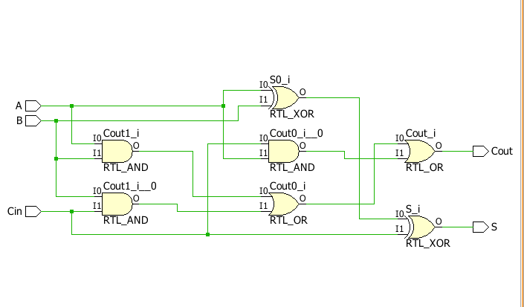

**TBW Code:**

entity FULLADD_TBW is

-- Port ( );

end FULLADD_TBW;

architecture Dataflow of FULLADD_TBW is

component FULLADD_DF is

Port ( A : in STD_LOGIC;

B : in STD_LOGIC;

Cin : in STD_LOGIC;

S : out STD_LOGIC;

Cout : out STD_LOGIC);

end component;

signal A1: STD_LOGIC:='0';

signal B1: STD_LOGIC:='0';

signal Cin1: STD_LOGIC:='0';

signal S1: STD_LOGIC;

signal Cout1: STD_LOGIC;

begin

UUT: FULLADD_DF port map(A=>A1, B=>B1, Cin=>Cin1, S=>S1, Cout=>Cout1);

Stim_proc:process

begin

wait for 100ns;

A1<='0';

B1<='0';

Cin1<='1';

wait for 100ns;

A1<='0';

B1<='1';

Cin1<='0';

wait for 100ns;

A1<='0';

B1<='1';

Cin1<='1';

wait for 100ns;

A1<='1';

B1<='0';

Cin1<='0';

wait for 100ns;

A1<='1';

B1<='0';

Cin1<='1';

wait for 100ns;

A1<='1';

B1<='1';

Cin1<='0';

wait for 100ns;

A1<='1';

B1<='1';

Cin1<='1';

wait;

end process;

end Dataflow;

**TBW Waveform:**

# 

# 2:1 MUX DATA FLOW

**VHD CODE:**

entity MUX_2X1_DF is

Port ( A : in STD_LOGIC;

B : in STD_LOGIC;

S : in STD_LOGIC;

Y : out STD_LOGIC);

end MUX_2X1_DF;

architecture Dataflow of MUX_2X1_DF is

begin

Y<=(A AND (NOT S)) OR (B AND S);

end Dataflow;

**RTL Diagram:**

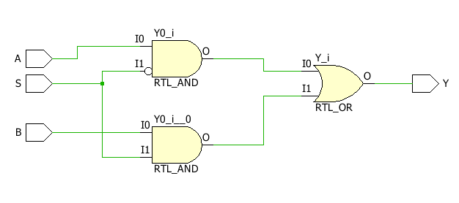

**TBW Code:**

entity MUX_2X1_DF_TBW is

-- Port ( );

end MUX_2X1_DF_TBW;

architecture Dataflow of MUX_2X1_DF_TBW is

component MUX_2X1_DF is

Port ( A : in STD_LOGIC;

B : in STD_LOGIC;

S : in STD_LOGIC;

Y : out STD_LOGIC);

end component;

signal a1: STD_LOGIC :='0';

signal b1: STD_LOGIC :='0';

signal e1: STD_LOGIC :='0';

signal y1: STD_LOGIC ;

begin

uut: MUX_2X1_DF port map (A=>a1, B=>b1, S=>e1, Y=>y1);

stim_proc: process

begin

wait for 100 ns;

a1<='0';

b1<='0';

e1<='0';

wait for 100 ns;

a1<='0';

b1<='0';

e1<='1';

wait for 100 ns;

a1<='0';

b1<='1';

e1<='0';

wait for 100 ns;

a1<='0';

b1<='1';

e1<='1';

wait for 100 ns;

a1<='1';

b1<='0';

e1<='0';

wait for 100 ns;

a1<='1';

b1<='0';

e1<='1';

wait for 100 ns;

a1<='1';

b1<='1';

e1<='0';

wait for 100 ns;

a1<='1';

b1<='1';

e1<='1';

wait;

end process;

end Dataflow;

**TBW Waveform:**

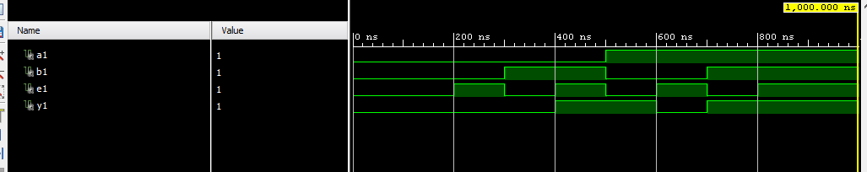

# 2:1 MUX BEHAVIORIAL

**VHD CODE:**

entity MUX_2X1_BH is

Port ( A : in STD_LOGIC;

B : in STD_LOGIC;

S : in STD_LOGIC;

Y : out STD_LOGIC);

end MUX_2X1_BH;

architecture Behavioral of MUX_2X1_BH is

begin

process(A,B)

begin

if (S='0')then

Y<=A;

else

Y<=B;

end if;

end process;

end Behavioral;

**RTL Diagram:**

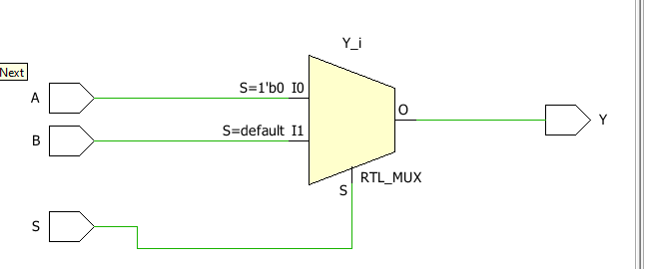

**TBW Code:**

entity MUX_2X1_BH_TBW is

-- Port ( );

end MUX_2X1_BH_TBW;

architecture Behavioral of MUX_2X1_BH_TBW is

component MUX_2X1_BH is

Port ( A : in STD_LOGIC;

B : in STD_LOGIC;

S : in STD_LOGIC;

Y : out STD_LOGIC);

end component;

signal a1: STD_LOGIC :='0';

signal b1: STD_LOGIC :='0';

signal e1: STD_LOGIC :='0';

signal y1: STD_LOGIC ;

begin

uut: MUX_2X1_BH port map (A=>a1, B=>b1, S=>e1, Y=>y1);

stim_proc: process

begin

wait for 100 ns;

a1<='0';

b1<='0';

e1<='0';

wait for 100 ns;

a1<='0';

b1<='0';

e1<='1';

wait for 100 ns;

a1<='0';

b1<='1';

e1<='0';

wait for 100 ns;

a1<='0';

b1<='1';

e1<='1';

wait for 100 ns;

a1<='1';

b1<='0';

e1<='0';

wait for 100 ns;

a1<='1';

b1<='0';

e1<='1';

wait for 100 ns;

a1<='1';

b1<='1';

e1<='0';

wait for 100 ns;

a1<='1';

b1<='1';

e1<='1';

wait;

end process;

end Behavioral;

**TBW Waveform:**

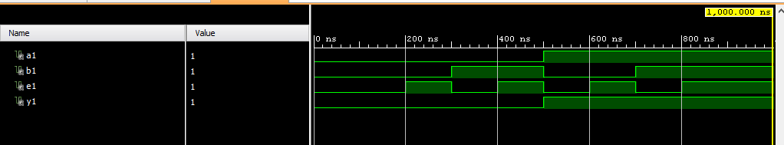

**4:1 mux dataflow**

**VHD CODE:**

entity multi41 is

Port ( IP : in STD_LOGIC_VECTOR (3 downto 0);

S : in STD_LOGIC_VECTOR (1 downto 0);

Y : out STD_LOGIC);

end multi41;

architecture Dataflow of multi41 is

begin

Y<=IP(0) When S="00"

else IP(1) When S="01"

else IP(2) When S="10"

else IP(3);

end Dataflow;

**RTL Diagram:**

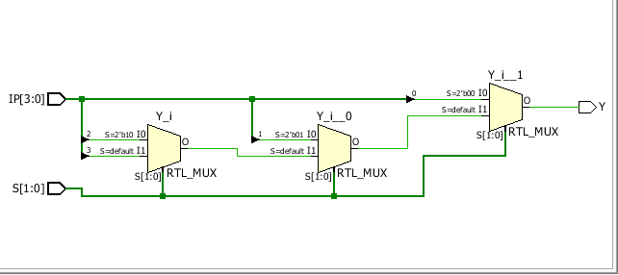

**TBW Code:**

entity multi41_tbw is

-- Port ( );

end multi41_tbw;

architecture Dataflow of multi41_tbw is

component multi41 is

Port ( IP : in STD_LOGIC_VECTOR (3 downto 0);

S : in STD_LOGIC_VECTOR (1 downto 0);

Y : out STD_LOGIC);

end component;

signal IP1:STD_LOGIC_VECTOR(3 downto 0):="1010";

signal S1:STD_LOGIC_VECTOR(1 downto 0):="00";

signal Y1:STD_LOGIC;

begin

uut: multi41 port map (IP=>IP1,S=>S1, Y=>Y1);

stim_proc: process

begin

wait for 100 ns;

S1<="00";

wait for 100 ns;

S1<="01";

wait for 100 ns;

S1<="10";

wait for 100 ns;

S1<="11";

wait;

end process;

end Behavioral;

**TBW Waveform:**

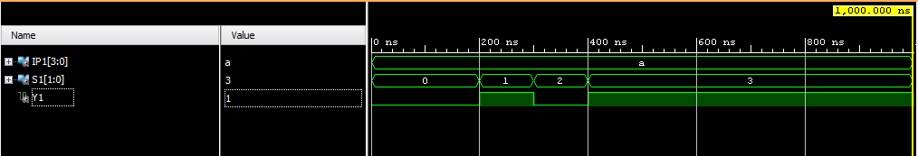

**BEHAVIARAL 4:1 MULTI**

**VHD CODE:**

entity MULTI41_BF is

Port ( IP : in STD_LOGIC_VECTOR (3 downto 0);

S : in STD_LOGIC_VECTOR (1 downto 0);

Y : out STD_LOGIC);

end MULTI41_BF;

architecture Behavioral of MULTI41_BF is

begin

process(IP,S)

begin

case S is

when "00"=>Y<=IP(0);

when "01"=>Y<=IP(1);

when "10"=>Y<=IP(2);

when "11"=>Y<=IP(3);

when others=>NULL;

end case;

end process;

end Behavioral;

**RTL Diagram:**

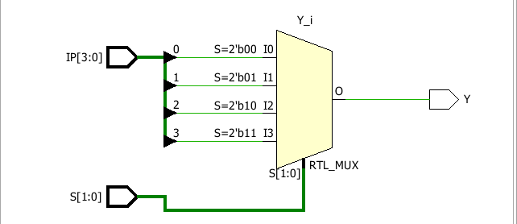

**TBW Code:**

entity MULTI41_BF_TBW is

-- Port ( );

end MULTI41_BF_TBW;

architecture Behavioral of MULTI41_BF_TBW is

component MULTI41_BF is

Port ( IP : in STD_LOGIC_VECTOR (3 downto 0);

S : in STD_LOGIC_VECTOR (1 downto 0);

Y : out STD_LOGIC);

end component;

signal IP1:STD_LOGIC_VECTOR(3 downto 0):="1010";

signal S1:STD_LOGIC_VECTOR(1 downto 0):="00";

signal Y1:STD_LOGIC;

begin

uut: MULTI41_BF port map (IP=>IP1,S=>S1, Y=>Y1);

stim_proc: process

begin

wait for 100 ns;

S1<="00";

wait for 100 ns;

S1<="01";

wait for 100 ns;

S1<="10";

wait for 100 ns;

S1<="11";

wait;

end process;

end Behavioral;

**TBW Waveform:**

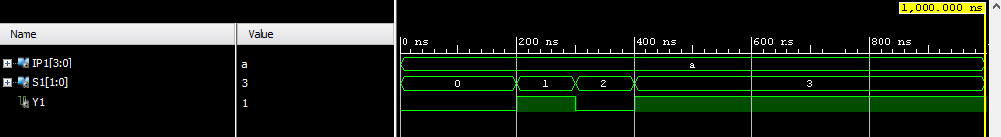

**3:8 DECODER DATAFLOW**

**VHD CODE:**

entity dec38 is

Port ( IP : in STD_LOGIC_VECTOR (2 downto 0);

OP : out STD_LOGIC_VECTOR (7 downto 0));

end dec38;

architecture dataflow of dec38 is

begin

OP(0)<='1' when IP= "000" else '0';

OP(1)<='1' when IP ="001" else '0';

OP(2)<='1' when IP ="010" else '0';

OP(3)<='1' when IP ="011" else '0';

OP(4)<='1' when IP ="100" else '0';

OP(5)<='1' when IP ="101" else '0';

OP(6)<='1' when IP ="110" else '0';

OP(7)<='1' when IP ="111" else '0';

end Dataflow;

**RTL Diagram:**

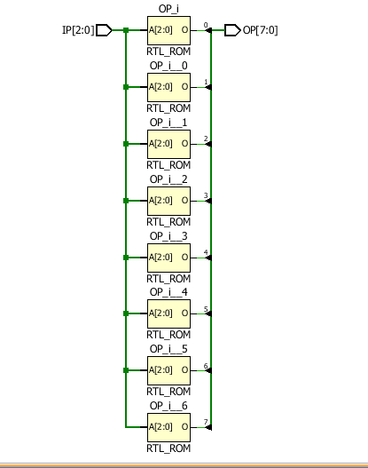

**TBW Code:**

entity dec38_tbw is

-- Port ( );

end dec38_tbw;

architecture dataflow of dec38_tbw is

component dec38 is

Port ( IP : in STD_LOGIC_VECTOR (2 downto 0);

OP : out STD_LOGIC_VECTOR (7 downto 0));

end component;

signal IP1:STD_LOGIC_VECTOR(2 downto 0):="000";

signal OP1:STD_LOGIC_VECTOR(7 downto 0);

begin

uut: dec38 port map (IP=>IP1,OP=>OP1);

stim_proc: process

begin

wait for 100 ns;

IP1<="000";

wait for 100 ns;

IP1<="001";

wait for 100 ns;

IP1<="010";

wait for 100 ns;

IP1<="011";

wait for 100 ns;

IP1<="100";

wait for 100 ns;

IP1<="101";

wait for 100 ns;

IP1<="110";

wait for 100 ns;

IP1<="111";

end process;

end dataflow;

**TBW Waveform:**

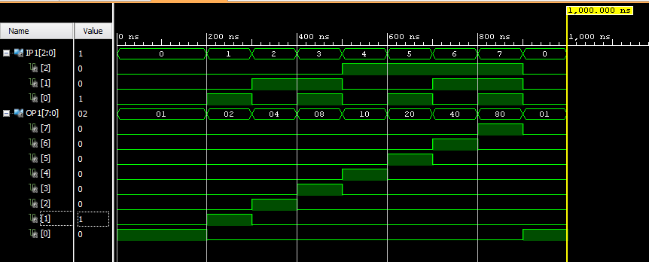

**3:8 DECODER BEHAVIORAL**

**VHD CODE:**

entity DECODER_BDF is

Port ( ip : in STD_LOGIC_VECTOR (2 downto 0);

op : out STD_LOGIC_VECTOR (7 downto 0));

end DECODER_BDF;

architecture Behavioral of DECODER_BDF is

begin

process(ip)

begin

op<="00000000";

case ip is

when "000" =>op(0)<='1';

when "001" =>op(1)<='1';

when "010" =>op(2)<='1';

when "011" =>op(3)<='1';

when "100" =>op(4)<='1';

when "101" =>op(5)<='1';

when "110" =>op(6)<='1';

when "111" =>op(7)<='1';

when others=>NULL;

end case;

end process;

end Behavioral;

**RTL Diagram:**

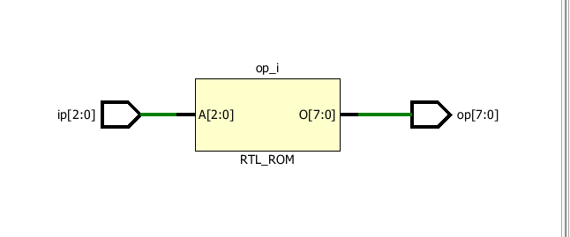

**TBW Code:**

entity DECODER_BDF_TBW is

-- Port ( );

end DECODER_BDF_TBW;

architecture Behavioral of DECODER_BDF_TBW is

component DECODER_BDF is

Port ( ip : in STD_LOGIC_VECTOR (2 downto 0);

op : out STD_LOGIC_VECTOR (7 downto 0));

end component;

signal ip1: STD_LOGIC_VECTOR (2 downto 0) :="000";

signal op1: STD_LOGIC_VECTOR (7 downto 0) :="00000000" ;

begin

uut: DECODER_BDF port map (ip=>ip1,op=>op1);

stim_proc: process

begin

wait for 100ns;

ip1<="000";

wait for 100ns;

ip1<="001";

wait for 100ns;

ip1<="010";

wait for 100ns;

ip1<="011";

wait for 100ns;

ip1<="100";

wait for 100ns;

ip1<="101";

wait for 100ns;

ip1<="110";

wait for 100ns;

ip1<="111";

end process;

end Behavioral;

**TBW Waveform:**

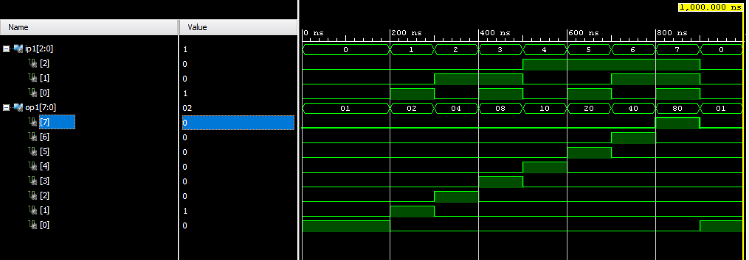

**FULL ADDER STRUCTURE**

**VHD CODE:**

entity FULL_ADDER_STRUCTURAL is

Port ( X : in STD_LOGIC;

Y : in STD_LOGIC;

Z : in STD_LOGIC;

Carry : out STD_LOGIC;

Sum : out STD_LOGIC);

end FULL_ADDER_STRUCTURAL;

architecture Structural of FULL_ADDER_STRUCTURAL is

component HFADD_DF is

Port ( A : in STD_LOGIC;

B : in STD_LOGIC;

S : out STD_LOGIC;

C : out STD_LOGIC);

end component;

component OR_Gate_DF is

Port ( A : in STD_LOGIC;

B : in STD_LOGIC;

C : out STD_LOGIC);

end component;

signal S1:STD_LOGIC;

signal C1:STD_LOGIC;

signal C2:STD_LOGIC;

begin

L1:HFADD_DF Port Map(X,Y,S1,C1);

L2:HFADD_DF Port Map(S1,Z,SUM,C2);

L3:OR_Gate_DF Port Map(C1,C2,CARRY);

end structural;

**RTL Diagram:**

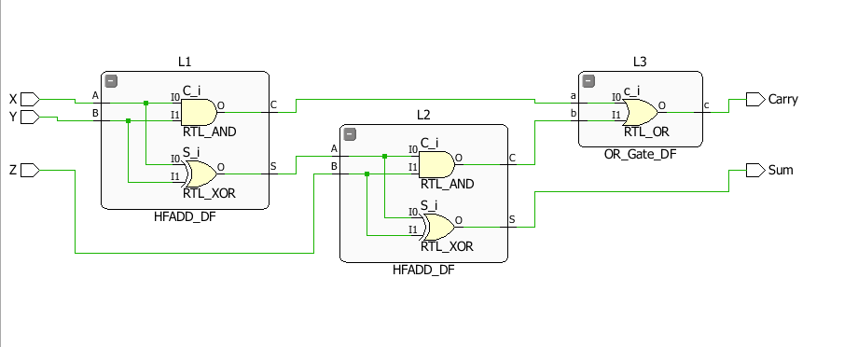

**TBW Code:**

entity FULL_ADDER_STRUCTURAL_TBW is

-- Port ( );

end FULL_ADDER_STRUCTURAL_TBW;

architecture structural of FULL_ADDER_STRUCTURAL_TBW is

component FULL_ADDER_STRUCTURAL is

Port ( X : in STD_LOGIC;

Y : in STD_LOGIC;

Z : in STD_LOGIC;

Sum : out STD_LOGIC;

Carry : out STD_LOGIC);

end component;

signal a1: STD_LOGIC :='0';

signal b1: STD_LOGIC :='0';

signal e1: STD_LOGIC :='0';

signal c1: STD_LOGIC ;

signal d1: STD_LOGIC ;

begin

uut: FULL_ADDER_STRUCTURAL port map (X=>a1, Y=>b1, Z=>e1, Sum=>c1,Carry=>d1);

stim_proc: process

begin

wait for 100 ns;

a1<='0';

b1<='0';

e1<='0';

wait for 100 ns;

a1<='0';

b1<='0';

e1<='1';

wait for 100 ns;

a1<='0';

b1<='1';

e1<='0';

wait for 100 ns;

a1<='0';

b1<='1';

e1<='1';

wait for 100 ns;

a1<='1';

b1<='0';

e1<='0';

wait for 100 ns;

a1<='1';

b1<='0';

e1<='1';

wait for 100 ns;

a1<='1';

b1<='1';

e1<='0';

wait for 100 ns;

a1<='1';

b1<='1';

e1<='1';

wait;

end process;

end structural;

**TBW Waveform:**

